Exercise 14

1. Our CEO falls in love with the petite Web Developer. ‘Anamika Pandit’. She now wants her last name to be changed to ‘Sharma’

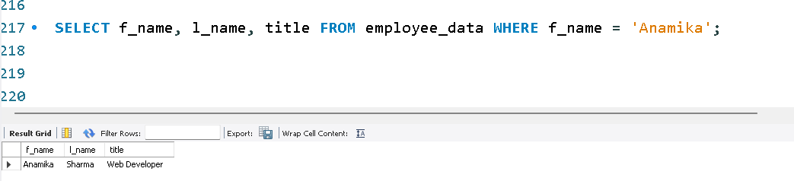

UPDATE employee_data

SET l_name = 'Sharma'

WHERE f_name = 'Anamika' AND l_name = 'Pandit';

SELECT f_name, l_name, title FROM employee_data WHERE f_name = 'Anamika';

2. All multimedia programmers now want to be called Multimedia Specialist

UPDATE employee_data

SET title = 'Multimedia Specialist'

WHERE title = 'Multimedia Programmer';

SELECT f_name, l_name, title FROM employee_data WHERE title = 'Multimedia Specialist';

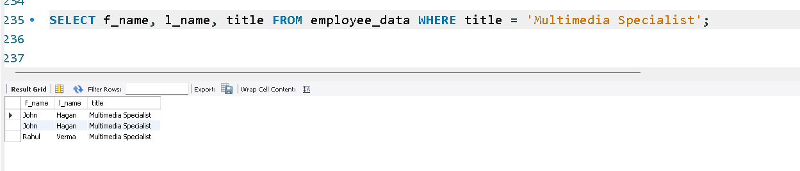

3. After this marriage, the CEO gives everyone a raise. Increase the salaries of all employees (except the CEO) by $10,000.

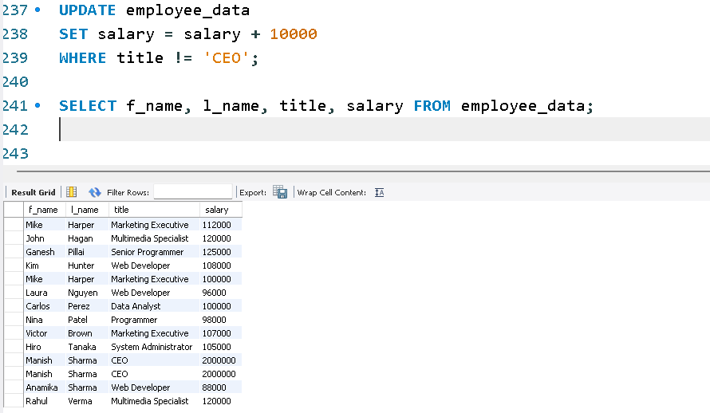

UPDATE employee_data

SET salary = salary + 10000

WHERE title != 'CEO';

SELECT f_name, l_name, title, salary FROM employee_data;